In________, an animal learns to ignore a repeated, irrelevant stimulus
A. Habituation
B. Taxis
C. Tropism
D. Imprinting
ANSWER: A
An example of learning by _________ is the one observed in squirrels
A. Habituation
B. Taxis
C. Tropism
D. Imprinting
ANSWER: A
If the signal comes from an individual who has caused many false alarms, its signal will be
A. Noticed
B. Ignored
C. Encountered
D. Perceived
ANSWER: B
Normally when one squirrel feels threatened, the others hear its signal and
A. Release chemicals to inform others
B. Communicated to other members
C. Ignore it
D. Go to the nearest refuge
ANSWER: D
Habituation is highly
A. Specific
B. Adaptive
C. Innate
D. Inborn
ANSWER: B
________ is a form of learning in which a very young animal fixes its attention on the first object with which it has visual, auditory, or tactile experience and thereafter follows that object
A. Habituation
B. Imprinting
C. Taxis
D. Tropism
ANSWER: B
Habituation, imprinting are
A. Innate behavior
B. Inborn behavior
C. Learned behavior
D. All of these
ANSWER: C
Who investigated the mechanisms of imprinting?
A. B.F. Skinner
B. Konrad Lorenz
C. Pavlov
D. K. L Lashley
ANSWER: B
_______ has been intensively studied only in birds, especially chickens, ducks, and geese
A. Habituation
B. Imprinting
C. Taxis
D. Tropism
ANSWER: B
The specific time during which imprinting develops is called the
A. Sensitive period
B. Time period
C. Critical period
D. Heat period
ANSWER: C
After birth or hatching, the newborn follows another animal that it recognizes or marks as its mother this is an example of:
A. Habituation
B. Imprinting
C. Taxis
D. Tropism
ANSWER: B
________is the loss of a response to a stimulus after repeated exposure.
A. Habituation
B. Taxis
C. Tropism
D. Imprinting
ANSWER: A
Habituation is
A. Irreversible
B. Reversible
C. Both A and B
D. None of these
ANSWER: B
___________is learning that is limited to a specific time period in animal's life
A. Habituation
B. Taxis
C. Tropism
D. Imprinting
ANSWER: D
Imprinting is
A. Irreversible
B. Reversible
C. Both A and B
D. None of these
ANSWER: A

Konrad Lorenz showed that the principle imprinting stimulus in:
A. Pelican
B. Graylag goose
C. Ostrich
D. Rabbit
ANSWER: B
Classical conditioning is learning through association and was first demonstrated by
A. B.F. Skinner
B. Konrad Lorenz
C. Pavlov
D. K. L Lashley
ANSWER: C
Habituation, imprinting, Classical conditioning are
A. Innate behavior
B. Inborn behavior
C. Learned behavior
D. All of these
ANSWER: C
The most famous example of classical conditioning was Ivan Pavlov's experiment with:
A. Cat
B. Rat
C. Dogs
D. Chimpanzee
ANSWER: C
Pavlov's dog experiments played a critical role in the discovery of one of the most important concepts in psychology i.e
A. Habituation
B. Imprinting
C. Classical conditioning
D. Trial and error
ANSWER: C
Food is the ___________in Pavlov’s dog experiment
A. Unconditioned stimulus
B. Unconditioned response
C. Conditioned stimulus
D. Generalization
ANSWER: A
Salivating from the food in Pavlov’s dog experiment is
A. Unconditioned stimulus
B. Unconditioned response
C. Conditioned stimulus
D. Generalization
ANSWER: B
Operant conditioning also called
A. Classical conditioning
B. Habituation
C. Instrumental conditioning
D. Imprinting
ANSWER: C
Habituation, Imprinting, Classical conditioning, and Operant conditioning are
A. Innate behavior
B. Inborn behavior
C. Learned behavior
D. All of these
ANSWER: C
Who is referred to as the Father of operant conditioning?
A. B.F. Skinner
B. Konrad Lorenz
C. Pavlov
D. K. L Lashley
ANSWER: A
______________is a type of associative learning process through which the strength of a behavior is modified by reinforcement or punishment
A. Habituation
B. Imprinting
C. Classical conditioning
D. Operant conditioning
ANSWER: D
Skinner used a special box known as “Skinner Box” for his experiment on:
A. Cat
B. Rat
C. Dogs
D. Chimpanzee
ANSWER: B
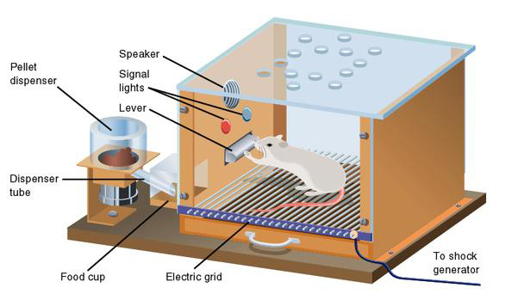
Observe the given picture and identify the experiment:
A. Habituation
B. Imprinting
C. Classical conditioning
D. Operant conditioning
ANSWER: D
Habituation, Imprinting, Classical conditioning, Operant conditioning, Latent learning and Insight learning are:
A. Innate behavior
B. Inborn behavior
C. Learned behavior
D. All of these
ANSWER: C
The experiment of Insight learning was performed by:
A. Wolfgang Kohler
B. Konrad Lorenz
C. Pavlov
D. K. L Lashley
ANSWER: A
Wolfgang Kohler performed his experiment on:
A. Cat
B. Rat
C. Dogs
D. Chimpanzee
ANSWER: D
A highly advanced and complex form of learning is:
A. Classical conditioning
B. Operant conditioning
C. Latent learning
D. Insight learning
ANSWER: D
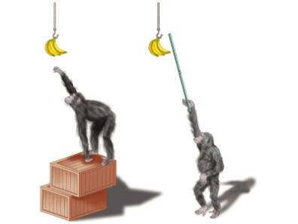
Observe the given picture and identify the experiment:
A. Instrumental conditioning
B. Insight learning
C. Classical conditioning
D. Operant conditioning
ANSWER: B
A type of learning that uses reason, especially to form conclusions, inferences, or judgments, to solve a problem
A. Instrumental conditioning
B. Insight learning
C. Classical conditioning
D. Operant conditioning
ANSWER: B

The bell is a neutral stimulus until the dog learns to associate the bell with food then the bell becomes a:
A. Unconditioned stimulus
B. Unconditioned response
C. Conditioned stimulus
D. Generalization
ANSWER: C

Famously described by zoologist Konrad Lorenz in the______, imprinting occurs when an animal forms an attachment to the first thing it sees upon hatching
A. 1789
B. 1587
C. 1930s
D. 1897
ANSWER: C

Habituation is:
A. Innate behavior
B. Inborn behavior
C. Learned behavior
D. All of these
ANSWER: C

